Appendix
Table 1 Structure of the interviews
 | Business owners | NGOs and State funded institutions
Introduction | - Focus of the company, Industry etc.  - Stakeholders  - Structure | - Clients – characteristics  - Services they provide
CSR | - Understanding of CSR  - Implementation of CSR + examples  - Motivation to implementation CSR  - Costs behind CSR  - Responsibility towards nearest area  - Cooperation with non-Czech companies (both in and outside Czech Republic) | State funded institutions  - CSR as a topic  - Process of picking and attracting clients (parameters, factors, controls)  - Comparison from abroad  - Special concern/program for primary sector companies  NGOs  - Process of picking and attracting clients (parameters, factors, controls)  - Special programs designed to focus on specific areas/regions  - Perception of CSR by clients  - Differences between SMEs and MNCs  - Special concern/program for primary sector companies
State/municipality | - Communication with municipality  - Support by EU/governments  - Knowledge of action plans | - Opinion on action plans  - Improvements for the action plans
Comments | - Suggestions  - Best practice  - Examples/inspiration/experience from abroad | - Suggestions/criticism  - Best practice  - Examples/inspiration/experience from abroad

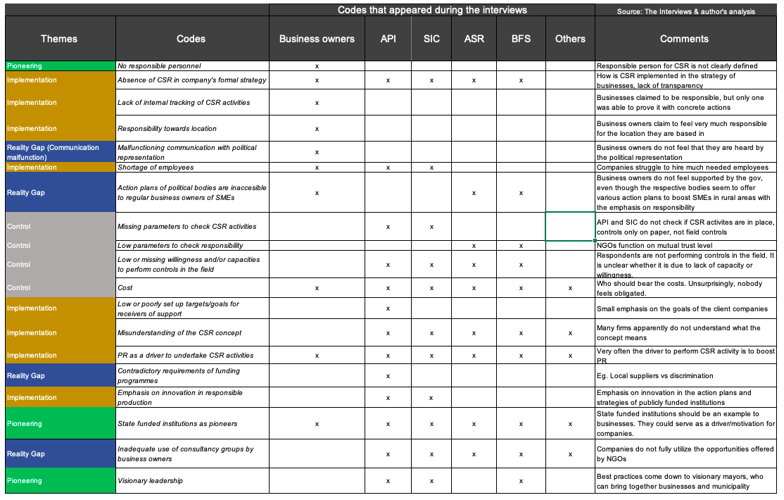
Table 2, Codes and themes of the content analysis

