FDI Allowed In Automatic Route

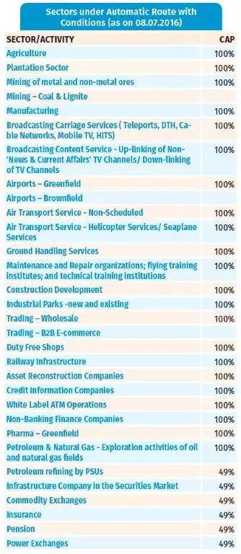
FDI Allowed In Government Sector
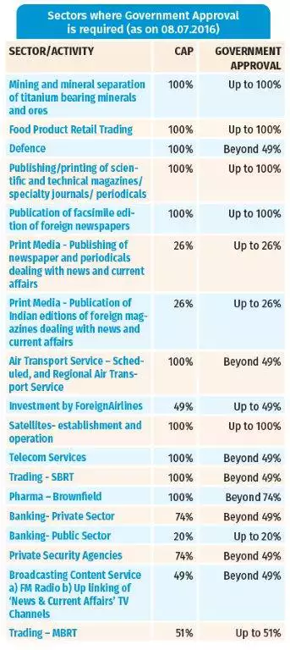
Mckinsey Win In India: Balance Scorecard
